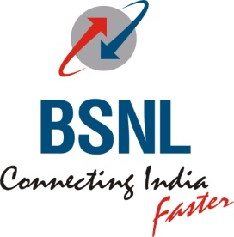
BHARAT SANCHAR NIGAM LIMITED
PRIORITY
(A Govt of India Enterprise)

Office of the General Manager (Sales & Marketing) – Consumer Mobility,
16, Greams Road, Tamilnadu Circle, Chennai – 600 006.
[CSC SECTION]

To
Heads of all SSAs
Tamilnadu Circle

No: CSC/T 118/Project Smile/ Vol-III/2010-2011/ 78 dated 15 /04/2011

Sub:Separate cash counter/ Queue at cash counters for handicapped customers reg

Ref: BSNL CO,ND Lr No 16-34/2010 CSC Dt 07/04/2011

*****
It is observed that handicapped persons have to wait for a long time in the normal queues at the cash counters to make payment of their bills. It has therefore been decided that all Customer Service Centers’ cash counters/ any other outlets of BSNL for collection of Bill payment for cash as well as cheque shall ensure the following , keeping in view the grievances of the physically handicapped persons.
- The officials manning the counters may be asked to give priority to such disabled customers who cannot stand / wait in the queues over other customers and render them services ahead of the queue.
- Such priority as above shall be displayed on boards near the cash counters.
- The staff incharge of Reception counters in Type I and Type II CSCs shall ensure that such disabled customers avail the priority in queues.
This has the approval of competent authority.

Sd/...
K SELVAKUMAR
DGM (CS)-CM

Copy to :
- All AGM (CSCs) Thru email
- Uploaded on Intranet.

